Q1) Write a class with FirstName, LastName & age field. Print Firstname, LastName & age using static block, static method & static variable respectively.

**Answer** 😀:

public class Test {

static String *FirstName*;

static String *LastName*;

static int *Age*;

static {

*FirstName*="Himanshu";

*LastName*="Panchal";

*Age*=22;

}

static void show() {

System.*out*.println("First Name="+*FirstName*+"\n");

System.*out*.println("Last Name="+*LastName*+"\n");

System.*out*.println("Age="+*Age*);

}

public static void main(String[] args)

{

Test tt=new Test();

tt.*show*();

}

}

**Output** 😀

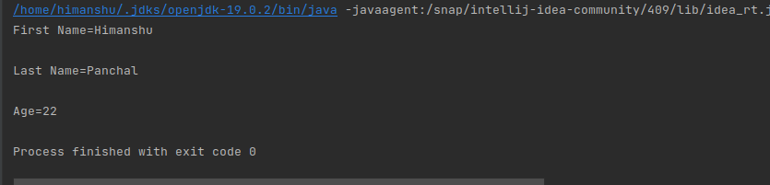

Q2) Write a program to read user input until user writes XDONE and then show the entered text by the user on command line.

**Answer** 😀:

import java.util.Scanner;

import java.util.*;

import java.lang.*;

class Xdone

{

public static void main(String args[])

{

List<String> user=new ArrayList<>();

System.*out*.println("Enter your data below(send XDONE to exit)");

Scanner input=new Scanner(System.*in*);

while(true)

{

String line=input.nextLine();

if("XDONE".equalsIgnoreCase(line))

{

break;

}

user.add(line);}

System.*out*.println(user);

}

}

**Output** 😀:

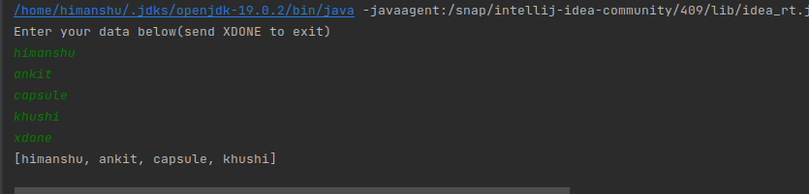

Q3) Write a java program to show following menu to the user:

*******Menu*******

1. Calculate Area of Circle

2. Calculate Circumference of a Circle

3. Exit.

Choose an option (1-3):

Take radius as user input.

Hint: Use Switch statement to act on the menu. Also area and circumference methods should be static.

**Answer** 😀:

import java.util.*;

class Circle

{

static float *PI*=22/7;

public static void main(String[] args)

{

int option;

double radius, circum, area;

Scanner sc=new Scanner (System.*in*);

System.*out*.println("MENU");

System.*out*.println("1.Calculate Area of Circle");

System.*out*.println("2.Calculate the circumference of Circle");

System.*out*.println("3.Exit");

System.*out*.print("Choose an option from 1-3");

option=sc.nextInt();

switch(option)

{

case 1:

System.*out*.print("Enter the radius of the circle: ");

radius=sc.nextDouble();

area=(*PI*\*(radius*radius));

System.*out*.print("The area of the circle is: "+area);

break;

case 2:

System.*out*.print("Enter the radius of the circle: ");

radius=sc.nextDouble();

circum=*PI*\*(2*radius);

System.*out*.print("The circumference of the circle is: "+circum);

break;

case 3:

System.*out*.println("No Solution");

break;

default:System.*out*.println("invalid choice!");

}

}

}

**OUTPUT** 😀 :

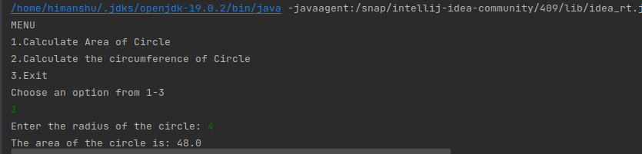

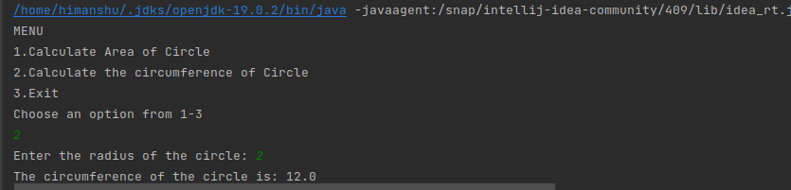

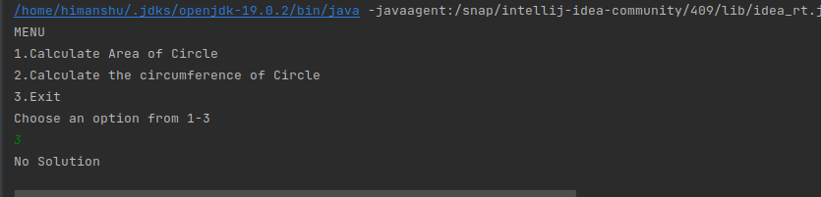

Q4) Create a two dimensional array of integers and display:

* sum of all elements of each column
* sum of all elements of each row

**Answer** **😀 :**

import java.util.Scanner;

class Sum {

static int *m* = 3;

static int *n* = 3;

static void row_sum(int arr[][])

{

int i, j, sum = 0;

System.*out*.print("\nFinding Sum of each row:\n");

for (i = 0; i < *m*; ++i) {

for (j = 0; j < *n*; ++j) {

sum = sum + arr[i][j];

}

System.*out*.println("Sum of the row " + i + " = "

+ sum);

sum = 0;

}

}

static void column_sum(int arr[][])

{

int i, j, sum = 0;

System.*out*.print(

"\n Sum of each column:\n");

for (i = 0; i < *m*; ++i) {

for (j = 0; j < *n*; ++j) {

sum = sum + arr[j][i];

}

System.*out*.println("Sum of the column " + i

+ " = " + sum);

sum = 0;

}

}

public static void main(String[] args)

{

int i, j;

int[][] arr = new int[*m*][*n*];

Scanner sc=new Scanner(System.*in*);

for (i = 0; i < *m*; i++)

{

System.*out*.println("Enter value for row "+i);

for (j = 0; j < *n*; j++)

arr[i][j] = sc.nextInt();

}

*row_sum*(arr);

*column_sum*(arr);

}

}

**Output** 😀 :

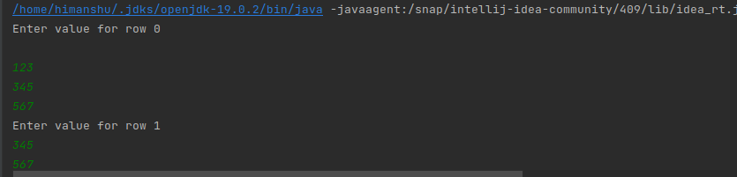

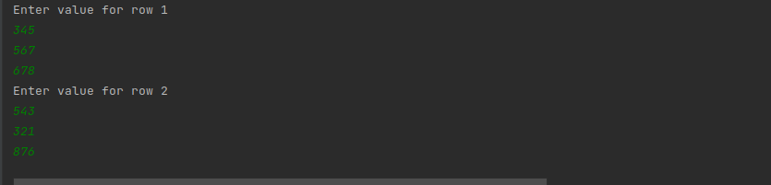

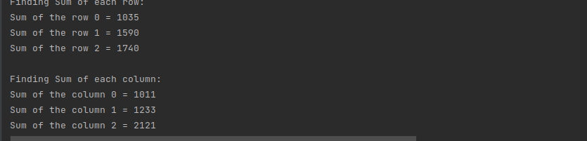

Q5) Create a class named Employee with fields firstname,lastname,age and designation.

The class should:

* have all types of constructors to initialize the object
* class should also have setter methods to update a particular field
* Override its toString method to display a meaningful message using all these fields.

public class Employee

{

private String firstName;

private String lastName;

private double salary;

public Employee()

{

firstName = "";

lastName = "";

salary = 0;

}

public Employee (String firstName, String lastName)

{

this.firstName = firstName;

this.lastName = lastName;

this.salary = 0;

}

public Employee( String firstName, String lastName, double s)

{

this.firstName = firstName;

this.lastName = lastName;

setSalary( s );

}

public String getFirstName()

{

return this.firstName;

}

public String getLastName()

{

return this.lastName;

}

public double getSalary()

{

return this.salary;

}

public void setFirstName( String firstName)

{

this.firstName = firstName;

}

public void setLastName ( String lastName)

{

this.lastName = lastName;

}

public void setSalary( double salary)

{

if (salary < 0 ) this.salary = 0;

else this.salary = salary;

}

public String toString()

{

return "First_Name="+firstName + "\n" +"Last_NAME="+ lastName + "\n" +"Salary="+salary;

}

public static void main(String args[])

{

Employee emp=new Employee("Himanshu","panchal",30000);

emp.getFirstName();

emp.getLastName();

emp.getSalary();

emp.setFirstName(emp.firstName);

emp.setLastName(emp.lastName);

emp.setSalary(emp.salary);

String info=emp.toString();

System.*out*.println(info);

}

}

Output

